Friday May 11th, 2018
2nd WORKSHOP on Structural Reforms in the EU

Organized by
Paul De Grauwe (European Institute, LSE)
Nauro Campos (Brunel University London)
Yuemei Ji (SSEES, UCL)

Venue: London School of Economics, COW.111 (the Canada Blanch seminar room), Portugal Street.
Workshop & project website:
http://www.structural-reforms.eu/

9.00-10.30 Session 1: Reforms and growth in Europe, Chair: Nauro Campos
(Format: 20min presentation followed by a 10min discussion for each paper)
Bas van Aarle (Leuven), Structural reforms and their effects on the EU
Comunale and Mongelli (ECB), Who did it? Growth and reforms in the euro area
Egert (OECD), Regulations, institutions and aggregate investment

10.30-11.00 Coffee break

11-12.30 Session 2: Crisis and reforms, Chair: Pasquale Foresti
(Format: 20min presentation followed by a 10min discussion for each paper)
Abritti & Weber (IMF), Institutions, cycles and growth in a monetary union (TBC)
Saka (LSE), Campos, De Grauwe and Ji (Brunel/LSE/UCL), Crisis and financial reforms
Hume (LSE), Crisis, imbalances and the SGP
Macchiarelli (Brunel/LSE), Monastiriotis &Lampropoulou (LSE), Transitions in the EU labour market: Structure, crisis and recovery

Lunch 12.30-1.30

1.30-3.30 pm Session 3: Reforms, austerity, and inequality, Chair: Yuemei Ji
(Format: 20min presentation followed by a 10min discussion for each paper)
Furceri & Jalles (IMF), Structural reforms and fiscal sustainability
Mushovel (LSE), Austerity and inequality
Martelli (LSE), Campos, De Grauwe and Ji (Brunel/LSE/UCL), Labour market reforms in the EU: What works? Issues of sequencing and complementarity

3.30-4.00 Coffee break

4.00-5.30 Session 4: Reform experiences, Chair: Corrado Macchiarelli
(Format: 20min presentation followed by a 10min discussion for each paper)
Marrazzo & Terzi (ECB), Structural reforms waves and economic growth
Tsakloglou (Athens Univ Ecn Bus) Greece: Integration, crisis and structural reforms
McQuinn & Varthalitis (ESRI), Structural reforms in Ireland

5.30-6.30 Keynote address, Chair: Paul De Grauwe

Professor Wendy Carlin (UCL)

Farewell drinks Friday 7pm at The George
Workshop Venue at London School of Economics:

The workshop will take place in COW1.11 (the Canada Blanch seminar room) in the European Institute (first floor), Portugal Street. The European Institute is in the building indicated with "COW" on the map of the LSE campus.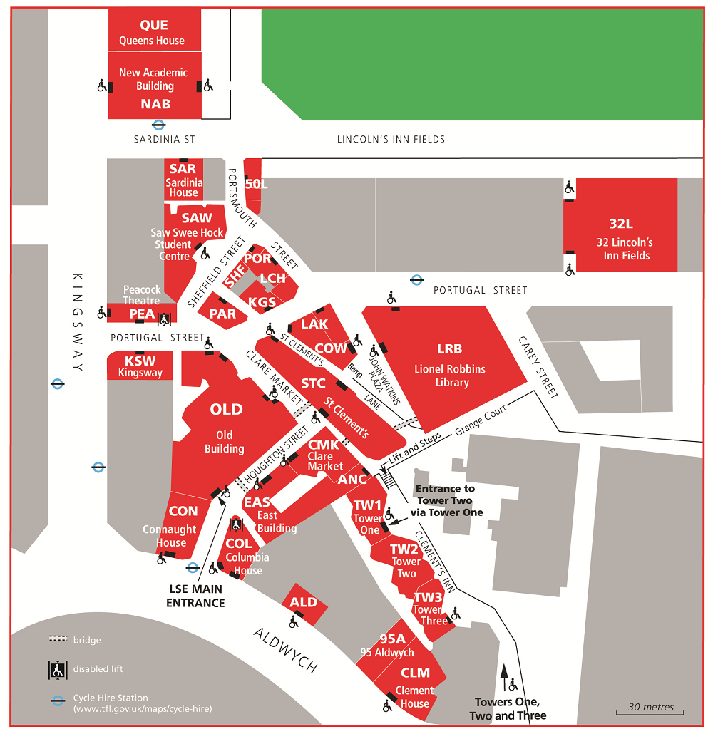

Hotel Information:

CLUB QUARTERS HOTEL
LINCOLN’S INN FIELDS

(5 minutes walking distance to the workshop venue)

61 Lincoln's Inn FieldsLondon, WC2A 3JW

+44 (0)20 7404 6640

https://clubquartershotels.com/locations/club-quarters-hotel-lincolns-inn-fields-london

How to get to LSE:

LSE is in central London at Aldwych, WC2A 2AE. The nearest underground station is Holborn, which is on the Central line or Piccadilly line. For more information, please check:
http://www.lse.ac.uk/mapsAndDirections/howToGetToLSE.aspx

